- Template Technical Summary
Team name
Team number (if appl.)
Team members (first names)
Team coach (full name)
Robotic set | e.g. LEGO, fischertechnik or self-assembled set
Weight | e.g. 1.1 kg
Size | Cm x cm x cm
Building materials | e.g. LEGO technic, fischertechnik building system, 3D printed material, Wood…
Controllers | e.g. LEGO SPIKE Prime, VEX IQ, Arduino nano
Battery | e.g. 7,5 V / 2.200 mAh
Sensors | List the type and number of sensors, e.g.:  2x color sensors, 1x distance sensor, 3x rotation sensors (one in each motor), 1x gyro sensor…
Motors | List the type and number of motors, e.g.:  2x LEGO Medium Angular Motor, 1x VEX IQ Smart Motor
Pneumatic system | Not used // Yes, LEGO Pneumatic system, max. pressure around 2 bar, 140 ml tanks
Programming Environment & language | LEGO SPIKE Prime App / Block programming  Python
Picture of robot with start- and stop-button marked | 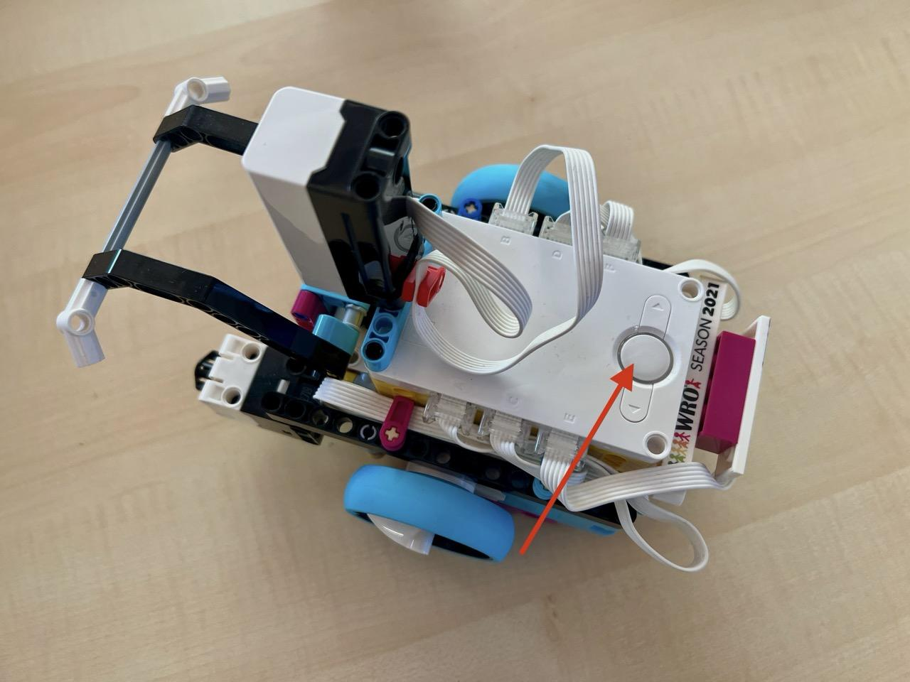  Replace with picture of your robot

